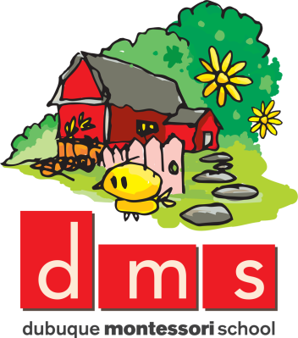

2605 Pennsylvania Ave. Dubuque, IA 52001

(563) 556-5105

WE NEED YOU!

Parent Volunteer Form 2019-2020

Your Name: Child’s Name:

Email Address: Phone #:

Parents play a vital role at Dubuque Montessori School by:

- Being members of the corporation
- Electing and serving on the Board of Directors
- Providing financial support and…
- Volunteering!!! We need your help in any way you are able!

Please check any activities you are interested in helping with and return this form by Friday, Sept. 6th.

__________ Board of Directors—Support the administrator in setting our school policy and charting the future of our school.

__________ Parent Club—Do you like to cook/bake or are you crafty? Help with ideas for teacher appreciation and organizing food for teacher in-service luncheons.

__________ Fundraising—Do you love to plan parties and events? Help coordinate projects that engage families and businesses in raising vital funds for our school!

__________ *Kids Care Club—Are you interested in assisting the students of DMS to learn about helping others in need? Help provide opportunities for our students to extend charity into the community.

__________ Publicity—Are you a social butterfly? Help build awareness of DMS and its activities by updating our marquee and creating/distributing other promotional materials.

__________ *Classroom Volunteer—Assist in the classroom on a consistent basis.

__________ Small Repair Jobs—Help keep school expenses down by doing small jobs around the school (e.g., fixing leaky faucet, etc.).

__________ Grounds Maintenance—Help with weeding, watering, tidying up grounds on a regular basis.

__________ Gardener—Oversee maintenance of our children’s garden.

__________ Summer weeding – Help with keeping the gardens and brick area clean
throughout the summer. Checking on it every couple weeks and weeding as
necessary.

__________ Tea Party – Cucumber sandwiches, strawberries, cookies, and flowers
needed close to Tea Party time for all classrooms, usually mid-April. More information will be sent as it gets closer.

__________ Other ways you can contribute to our school:

DMS has dedicated this school year as “The Year of Science.” Do you have any interests or special abilities that you would like to share with us? The children would love for you to come and share your knowledge and enthusiasm: ___________________________________________________________________________________________________________________________________________________________________________________________________________________________________________________________________________________________________________________________

Thank you for your vital support of our school!

We will contact you soon regarding your areas of interest. Thank you.

*Volunteer positions that include interaction with children require state and federal (fingerprinting) background checks under DHS Preschool and Child Care Center Licensing Standard law, section 109.6. Dubuque Montessori School is willing to cover the charges if you are willing to commit to a consistent schedule.

